**The National Institute of Engineering**

**AICTE ACTIVITY POINTS REPORT (20 Points)**

**ON**

**APMC Price Update System to Farmers**

**Submitted By**

**Hema B M [4NI19EE036]**

**Under the Guidance of**

**Ms. Ashwini G**

**Assistant Professor**

**Department of Electrical and Electronics Engineering**



**The National Institute of Engineering**

[An Autonomous Institute, Affiliated to Visvesvaraya Technological University, Belgaum]

**Manandavadi Road, Mysuru, Karnataka - 570008**

2022-2023

[An Autonomous Institute, Affiliated to VTU, Belgaum]

**Manandavadi Road, Mysuru, Karnataka – 570008**

# CERTIFICATE

Certified that the AICTE Activity Points Project entitled “**APMC Price Update System to Farmers”** carried out by **Ms.Hema B M** bearing **USN: 4NI19EE036** a bonafide student of **The National Institute of Engineering** in partial fulfillment for the award of **Bachelor of Engineering** in

**Electrical and Electronics Engineering** of the Visvesvaraya Technological University, Belagavi during the year 2022-23. It is certified that all theory/practicals/corrections/suggestions indicated for Activity Points have been executed under the directions of **Dr. Pradeepa H.** The project report has been approved as it satisfies the academic requirements in respect of AICTE Activity Points prescribed for the said degree.

S

,

**Dr. Pradeepa H Ashwini G**

Head Of Department Assistant Professor

Dept of EEE Department of E &EE

The National Institute of Engineering Mysuru

NIE - Mysore

**DECLARATION**

I, **Ms.Hema B M** bearing the USN **4NI19EE036**, student of 8th Semester B.E. Department of Electrical and Electronics Engineering, **The National Institute of Engineering**, Mysore declare that the AICTE Activity Project work entitled “**APMC Price Update System to Farmers**”, has been duly executed by me under the guidance of LGS Social Innovation and Research Centre (An unit of LGS Trust) and **Dr. Pradeepa H**, Professor, Department of Electrical and Electronics

Engineering, The National Institute of Engineering, Mysore. The Project report of the same is submitted in partial fulfilment of the requirement for the award of Bachelor of Engineering degree in Department of Electrical and Electronics Engineering by Visvesvaraya Technological University, Belgaum during the year 2022-2023.

Date: Hema B M

Place: Mysore 4NI19EE036

## ACKNOWLEDGEMENT

The satisfaction that accompanies the successful completion of the project report which would be complete only with the mention of the almighty God and the people who made it possible, whose report rewarded the effort with success of project presentation

We are grateful to **The National Institute of Engineering** for providing us an opportunity to enhance our knowledge through the project.

We express our sincere thanks to **Dr. Rohini N**, Principal, NIE-Mysuru for providing us an opportunity and means to present the project.

We express our heart full thanks to **Dr. Pradeepa H**, Professor and Head, Department of Electrical and Electronics Engineering, NIE-Mysuru for encouragement in our project work, whose cooperation and guidance helped in nurturing this project report.

We would like to express profound thanks to the project guide **Dr. Pradeepa H, Professor**, Project head and Internal Guide, Department of Electrical and Electronics Engineering for the keen interest and encouragement in our project presentation.

We extend our thanks to the **LGS Social Resource** **and Research Center** for their effort and endurance to bring out the best in us.

Finally, we would like to thank our family members and friends for standing with us through all times.

**Hema B M**

**[4NI19EE036]**

## ABSTRACT

The AICTE Activity Points has the objective of creating awareness of existing social issues to Engineering Students and allowing them to develop an engineering solution that will solve the issue thereby enhancing the Engineering Applied Skills and Social Entrepreneurship among Engineering Students. The social issue chosen in this project is “**APMC Price Update System to Farmers**”. The daily prices of farmers are volatile based on Seasons, Location and Demand. The system is very difficult to predict the prices as the requirements are not monotonous and changes on hour basis. This made the transparency level very weak to farmers in the price decision. However the available prices are not informed to farmers considering the unsolvable criterion such as distance, time and platform. This has caused the dominance of middlemen agents causing the loss to farmers. This project has 2 segments. First, is to understand the issue and process in the APMC System, second is the public survey, field visit to a APMC Centre and developing a solution to the existing system.

The Final probable solutions along with Financial, Legal and Beneficiary analysis to bridge the gap in APMC Price Transparency System is discussed. This solution has a potential to be implemented in the Practical world along with the necessary infrastructures.

## PROJECT FEATURES

|  |  |
| --- | --- |
| **Project Name:** | APMC Price Update System to Farmers |
| **Project Category as per AICTE Activity Points:** | To assist the Marketing of Rural Produce |
| **Total Hours of Involvement:** | 15 days |
| **Total Activity Point Earned by this Project:** | 20 Points |



***An init***

***i***

***ative of***

**LGS TRUST ®**

**LGS**

**Social Innovation and Research Centre**



**NGO Darpan Id**

**KA/2020/0254492**

**GSTIN**

**29**

**3**

**AABTL9441K1Z**

**Ms**

**.**

**Hema B M**

*for*

*participating in a*

*15 days of Theory and Practical*

*on*

*Project*

*“*

*APMC Price Update System to Farmers*

*” designed to award*

*2*

*0*

*Activity*

*Points*

*towards the “*

*AICTE Activity Points*

*Program*

*”*

*from*

*15*

*-*

*Apr*

*-*

*202*

*3*

*to*

*30*

*-*

*Apr*

*-*

*202*

*3*



**Activity**

**Completion**

**Certificate**



**USN**

**:**

4

4NI19EE034

**Certificate ID**

**:**

APM

0

3

C

51

5

4



**College:**

NIE

**Course:**

BE

**Branch:**

EEE

**Mr. B G Shivanna**

**Mr.**

**Harsha S**

**Mr**

**s**

**.**

**B Kowsalya**

**LGS Social Innovation and Research Centre**

An Initiative of

**LGS Trust**

®

No.126, First Floor, Aadri, 7

th

Cross, 2

nd

Main, Hoysalanagar, Sunkadakatte, Bangalore

-

560091

**CERTIFICATE**

Certified that the project work entitled “

**APMC**

**Price Update System to Farmers**

”

carried out

by

**M**

**s.**

**Hema B M**

bearing

**USN:**

**4**

**NI19EE**

**0**

**36**

and

NGO

Certificate

ID

**APM**

**0**

**3**

**C**

**51**

**5**

**4**

a

bonafide student of

**The National Institute of Engineering**

in

executing tasks for

1

Days

510

needed to earn

**2**

**0**

**AICTE**

**Activity**

**Points**

for

the

AICTE Activity Points P

roject on

the partial

fulfillment for the award of

**Bachelor of Engineering**

in

Department of

Electrical and

Electronics Engineering

of the Visvesvaraya Technological Universit

y, Belagavi during the

year 202

2

-

2

3

.

It is certified that the student has participated in all the activities assigned by Centre that can

impart knowledge on the project. It is also certified that student has involved in making the best

model to help the society and solve the social pr

oblem related to the project.

The tasks created

as per the terms of University are executed by the Student. We, the NGO find that student has

met the criterion to award the

2

0

Activity Points as per the University rules.



Signature of NGO Resource Person

**Mr. Harsha S**

M.Tech,

PGDFCS

LGS

Social Innovation and Research Centre

harshas@lgstrust.com

Ph: 9448165040 / 9742942597

Signature of NGO Key

Person

**Mr. B G Shivanna**

President, LGS Trust

lgstrustindia@gmail.com

Ph: 9448165040 /

9880436959

Signature of NGO Resource Person

**Mr. Harsha S**

M.Tech,

PGDFCS

LGS Social Innovation and Research Centre

harshas@lgstrust.com

Ph: 9448165040 / 9742942

597

**LGS Social Innovation and Research Centre**

An Initiative of

**LGS Trust**

®

No.126, First Floor, Aadri, 7

th

Cross, 2

nd

Main, Hoysalanagar, Sunkadakatte, Bangalore

-

560091

**CERTIFICATE**

Certified that the project work entitled

**“**

**APMC Price Update System to Farmers**

**”**

was carried

out by “

**LGS Social Innovation and Research Centre,**

**an initiative of LGS Trust**

” under the

guidance of

**Mr.**

**B.G. Shivanna**

, a Red Cross Coordinator,

NSS Coordinator,

Himalaya Wood

Badge Holder, Scouts and Guides Instructor

My suggestion was considered in creating the syllabus, conducting theory class

–

Survey

–

Case

Study and Practical Surveys. The implementation was done as per the standards to make

students learn the social problems and come up with the solution for the same.

The procedures followed by the LGS Social Innovation and Research Centr

e towards this project

to earn

**2**

**0**

**AICTE Activity Points**

for the student is satisfactory as per my experience in the Red

Cross

-

Scouts and Guides,



Signature of

Red Cross Coordinator

**Mr.**

**B. G. Shivanna**

B.A., M.P.Ed,

Red Cross Coordinator

Ph:

9448165040 / 9880436959

**APMC Price Update System to Farmers**

## CONTENTS

|  |  |  |
| --- | --- | --- |
| Chapter 01 | Introduction to AICTE Activity Points | 1 |
| Chapter 02 | Problem Statement | 2 |
| Chapter 03 | Vision & Mission of Project | 3 |
| Chapter 04 | LGS Social Innovation and Research Centre | 4 |
| Chapter 05 | Introduction to APMC System | 4 |
| Chapter 06 | Market Alternate to APMC System | 7 |
| Chapter 07 | APMC Price Communication Methods and its Impact | 8 |
| Chapter 08 | Engineering Solution from LGS Trust | 9 |
| Chapter 09 | Public Survey Questions | 10 |
| Chapter 10 | Conclusion & References | 12 |
|  | **APPENDICES** |  |
| Appendix 01 | Public Survey Results | 14 |
| Appendix 02 | Field Visit Summary | 18 |
| Appendix 03 | Providing Solution as an Engineer | 21 |
| Appendix 04 | Case Study Questions | 23 |

# Chapter 01 Introduction to AICTE Activity Points

Indian government via AICTE and Universities has mandated the Engineering Students to earn the AICTE

Activity Points in the Engineering Curriculum with the objective of

* Enhancing the Application Skill of Students
* Make students understand the insights of Indian Society Issues
* Developing Engineering Solutions to Indian Society Issues
* Promoting Social Entrepreneurship among Engineering Students
* An attempt to solve Indian Society Issues with Technology

In comparison, Engineering Solution is seen in less than 10% in the following segments of Rural India:

* Rural Development
* Agriculture
* Animal Husbandry
* Agriculture Marketing
* Rural Employment
* Promoting Local Tourism
* Women Empowerment
* Reducing Malnutrition
* Solid Waste Management

Today atleast one CEO of top 10 companies in world is from India. But India itself is struggling to solve the social problems.

People interested to solve Rural Problems are:

* Lacking the technology knowledge
* Lacking the Implementation Strategy
* Lacking the introduction of Sustainability to the Projects
* Lacking the public involvement
* Lacking the professionalism in the projects

People with expertise in above segments are not interested to solve Rural Problems as:

* They prefer commercialization than Service
* Implementation has to start from elementary stage
* Lack of Public support in Rural Areas
* Lack of Infrastructures in Rural Areas
* Decreasing population in Rural Areas
* Unorganized segments are seen in Rural Areas

AICTE Activity Points is very essential in shaping India for the sustainable life style

# Chapter 02 Problem Statement

Today Indian Agriculture is witnessing the revolution in methods. The changes are brought in

* Growing Dynamics
* Marketing Dynamics

While technology enabled Organic and Natural methods are introduced in growing dynamics, the technology enabled B2B and B2C systems are introduced in marketing dynamics.

However, as per the government policies, only few organizations are permitted to purchase from farmer to avoid losses to farmers and bring stability in country food security. Government has established APMC – Agriculture Products Marketing Committee in major taluks of all states to ensure right sell price to farmers. We have 2477 APMC and 4843 sub markets in India. Government has framed many policies in favor of farmers.

Today, inspite of networked APMC’s, the transparency and communications are not seen in the

* Price Fixation of Agriculture Products
* Fixed price of Agriculture Products

If APMC Prices are availed to farmers in right time, the loss of farmers can be avoided. But the middlemen agents has started exploiting the farmers by providing inadequate data to farmers about the APMC Prices. In the era of availing the taxis in a minute, farmers are not getting the price of nearby APMC’s. This project is focused to resolve this issue by providing technology solution.

Listed Problem Statements associated to this Project are:

1. Common Platform to list the APMC Prices – Distance and Product wise – in a way understandable to farmer
2. Technology adoption to share the APMC prices in local languages
3. Adoption of Artificial Intelligence in APMC Prices Platform
4. Methodology to forecast to the Agri Products prices
5. Technology adoption to nullify the domination of middlemen in APMC Transactions

# Chapter 03 Vision of the Project

This project is aimed at the development of Social Entrepreneurship that can resolve the problem statements listed. However such initiation needs the equal participation of Management and Engineering Technology. Considering the scope of Project, the development of Start-up plan is proposed and implementation is planned for the future.

# Mission of the Project

In this project, with the availability of 15 days to complete the project, only following activities can be undertaken by keeping the Vision of Project as the basis.

Theoretical Understanding of the

* APMC and its Operations
* Possible ways of exploiting farmers in the Product Transactions
* Scope of Engineering Solutions in APMC Price Communications
* Ongoing research in the APMC Price Models

Practical tasks including

* Collecting answer to 125 questions from a total of 05 Individuals
* Collecting answers to 25 questions from each individual
* Field Visit to a APMC and interaction with the stakeholders
* Developing the public opinion on the APMC Price Transparency and Communication Structures
* Analyzing the public opinion on the need of Engineering Solution
* Understanding the effect of such solution platform in Society
* Severity of problem in society and Priority to be taken to address such issue

# Chapter 04 LGS Social Innovation and Research Centre

“LGS Social Innovation and Research Centre” is an initiative of the NGO “LGS Trust ®”. They are the social workers working on the Social Innovation. They are located in Bangalore. Their main objective is identifying the Social Problem, executing the survey, developing the solution on paper, implementing the prototype of the same. They are supporting students in the implementation of AICTE Activity Points. This project is implemented with their support.

**Mode of Implementation in this Project:**

As the project needs minimum of 15 days activity

# Chapter 05 Introduction to APMC System

Marketing and Sales are the major segment in any process. Farming / Agriculture is one such process which involves growing and selling as the 2 major steps. During and before independence, the farmers were exploited by the traders and middlemen by purchasing at the low price. Denial of Trade was the concept followed by traders wherein all traders were united in fixing the prices. As we can see, from that day till today merchants have become sustainable in finance and not the farmers.

After Independence, the Indian Government introduced APMR Acts - Agricultural Produce Marketing

Regulations Act that has the objective of setting Market Yards exclusively for the farmers that can

* Protect farmers from the exploitation of creditors
* Protect farmers from the exploitation of intermediaries

Provide right price to the farmer’s produce

* Provide platform to the farmers, buyers and auction agents to work for the sustainable market

Such markets were monitored by the committee called Agricultural Produce Marketing Committee – APMC. This committee has constitutional structure that makes sure all the provisions and policies in the APMR acts are followed. By this it is mandated that

* Farmers can sell only in Market Yards monitored by APMC’s through auction
* Buyers cannot purchase from Farmers outside the APMC Market Yards.
* APMC is under the supervision of State Government

Auction is the best method to make sure

* All buyers and sellers have equal contribution
* Big buyers cannot create shortage of products in market by purchasing all products

On a summary, The APMC is a regulatory and marketing council, developed by Indian state governments to protect Indian farmers from exploitation by large retailers. Also, it regulates the prices of the crops from the farms to the retail stores. The state governments of India through APMCs ensure that the prices of crops don’t get excessively increase. The primary duties and responsibilities of APMC include maintaining proper transparency in the pricing, keeping an eye on transactions, and the most important i.e., ensuring that the farmers get their payment on the same day, they sold their crops.

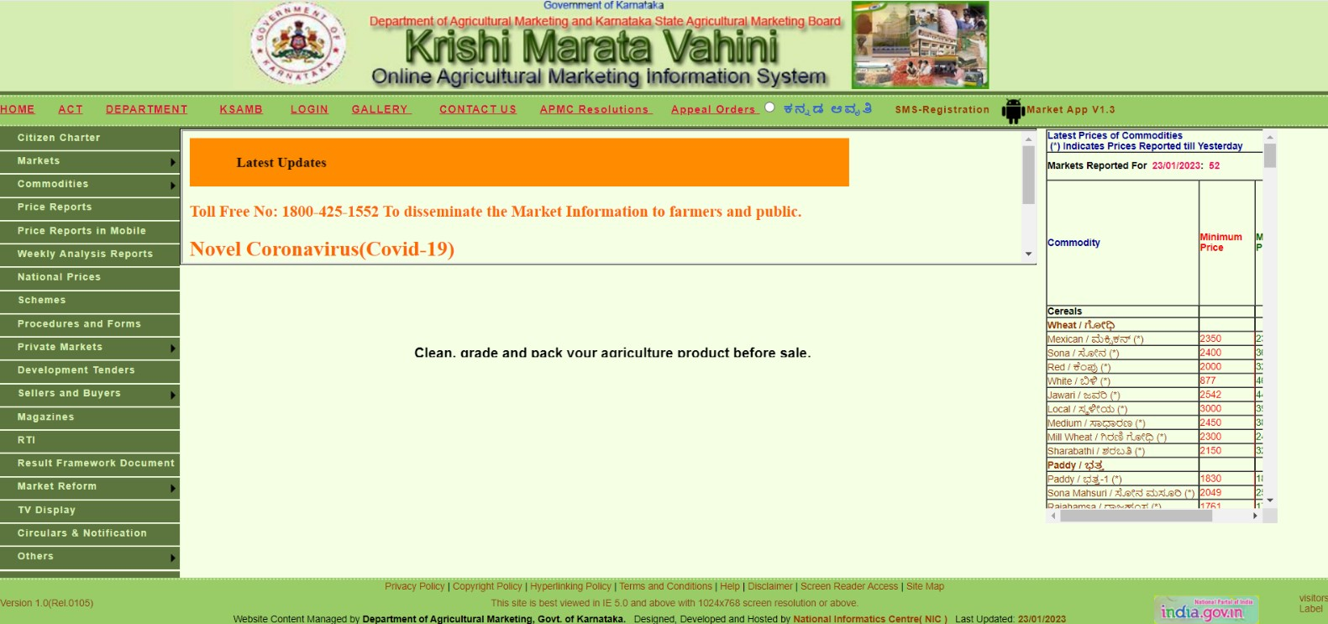

Following are the advantages of APMC System:

* Safeguard the farmers from exploitation by the creditors and other intermediaries.

Ensure that the farm to retail price does not spike unreasonably, and timely payments are made to the farmers via the auctions in the APMC markets.

* Provide storage facilities such as go-downs etc. to the farmers.
* Arrange farmer markets so that the farmers could sell their produce to the consumers directly. • Help in controlling price fluctuations

Following are the disadvantages of APMC System:

* **The monopoly of APMC** – Monopoly of any trade (barring few exceptions) is bad, whether it is by

some MNC corporation by

government or by any APMC.

It deprives farmers of better

customers and consumers from

original suppliers.

•

**Entry Barriers**

–

License fees

in these markets are

highly

prohibitive. In many markets,

farmers are not allowed to

operate.

Further,

over

and

above license fee, rent/value

for shops is quite high which

keeps away competition. At

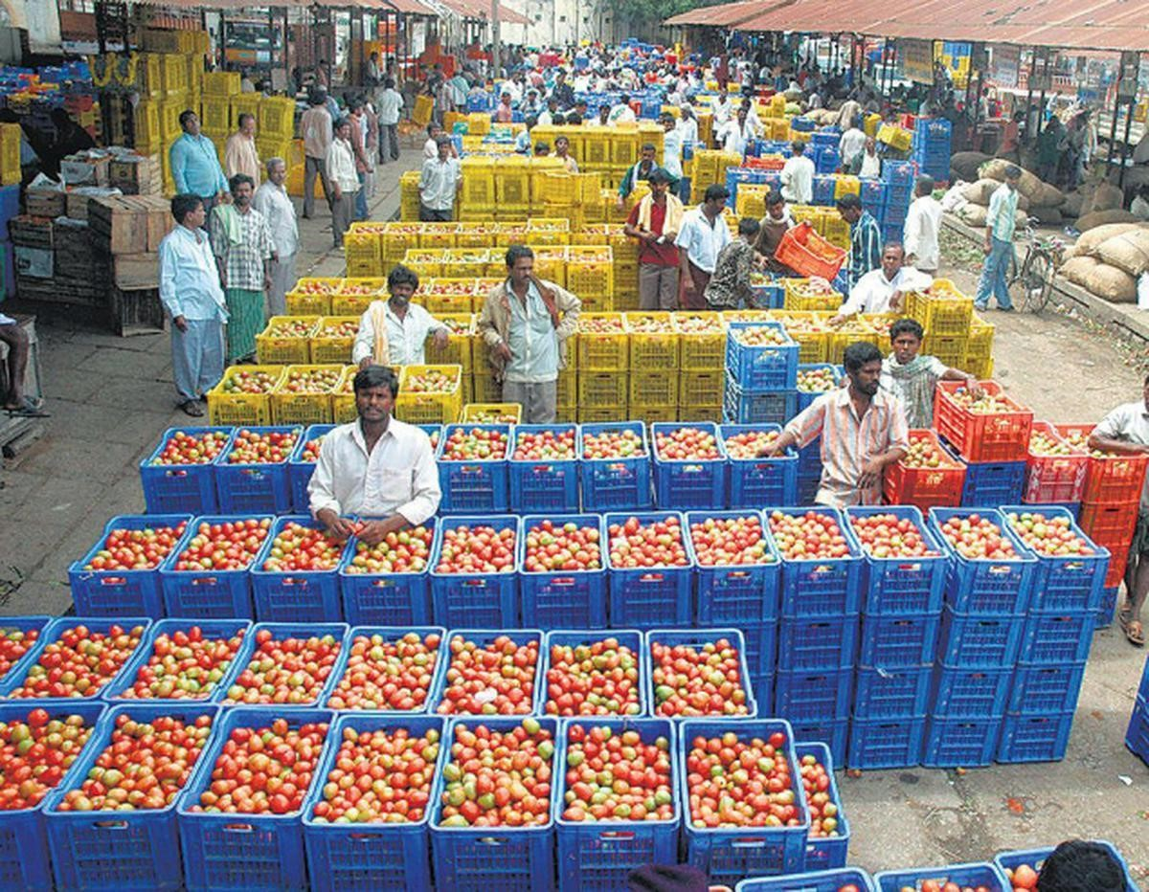

most places, only a group of the village/urban elite operates in APMC.

* **Cartelization** – It is quite often seen that agents in an APMC get together to form a cartel and deliberately restraint from higher bidding. Produce is procured at a manipulatively discovered price and sold at a higher price. Spoils are then shared by participants, leaving farmers in the lurch.
* **High commission, taxes, and levies** – Farmers have to pay commission, marketing fee, APMC cess which pushes up costs. Apart from this many states impose Value Added Tax.
* **Conflict of Interest** – APMC plays the dual role of regulator and Market. Consequently, its role as regulator is undermined by vested interest in the lucrative trade. They despite inefficiency won’t let go of any control. Generally, members and chairman are nominated/elected out of the agents operating in that market.

**Other Manipulations** – Agents have a tendency to block a part of the payment for unexplained or fictitious reasons. Farmer is sometimes refused a payment slip (which acknowledges sale and payment) which is essential for him to get a loan.

# Chapter 06 Markets Alternate to APMC System

India has 2,477 APMC Markets and 4,843 sub markets regulated by APMC’s. As each APMC works individually with their own constitution, the loopholes in the system is more. The agents and traders started dominating the system by occupying the Management and Auction roles. Such persons united and made farmers devoid of the benefits of APMC Systems. Today, the entire operations are done as per the will and wish of traders. It is very hard to see genuine farmers in the market yard. The management decreased transparency, increased the fee, underdeveloped the premises and rejected the online system. APMC premises earn in crores, traders earn in crores but farmers are in loss.

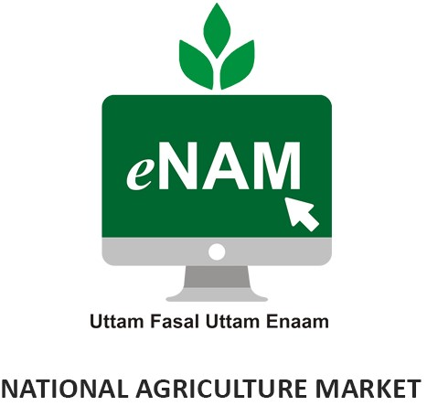

Considering the Indian Political System, the Centre is unable to control any of these features as the APMC is under the state government control. Hence to benefit the farmers across different states, the central government has introduced the online feature enabled market system called e-NAM. (Electronic – National Agriculture Market). It was launched by the Ministry of Agriculture, Government of India on 2016. It is managed by the committee by name – Small Farmers Agribusiness Consortium.

Features:

* Farmers have option to trade directly or via Commission Agents
* Farmers can use online mode to trade commodities

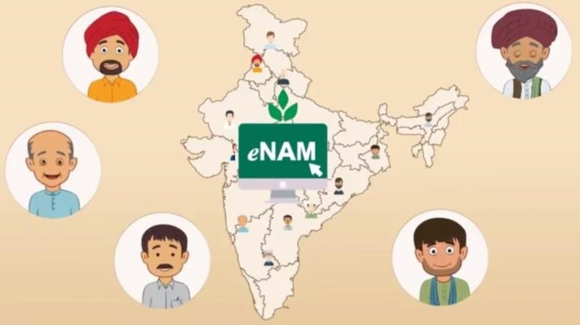

* Same day product lift and same day payment will happen
* Platform is linked with 60% of existent

APMC’s with 1 Crore+ Farmer

Memberships.

Though this system is beneficial, success is not huge considering the digital literacy of farmers and monopoly of traders along with lack of support from state governments. However the project is still active with the sustainable and exponential increase in the farmers transactions. For sure this system will be the future if the local transport support is provided. Process is mentioned in pictorial format.

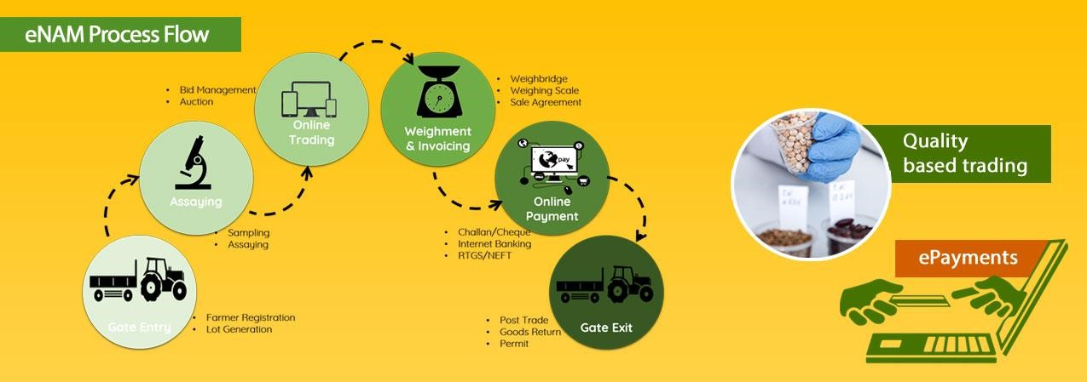

# Chapter 07 APMC Price Communication Methods and its Impact

APMC Prices are very important for a farmer to decide the harvest time and selling location. We see a difference of INR 5.00 to INR 50.00 on a product purchase price from one APMC to another. This is mainly due to the difference in demand and supply ratio. Traders encatch this information to make more profit. They make farmers devoid of such information. Purchase price information places a crucial role in the profit of farmers. At present, such informations are available to farmers by

* Website
* SMS

While website is the government owned, farmer has to browse through 7 web pages to know the prices in different APMC’s. SMS is the service provided for the government. Information is limited to only 5 selected products from single APMC. Considering the digital illiteracy of farmers, Indian government has not come up with any mode that communicates the price in regional language in a easy mode. An engineering solution is inevitable in this mode for the easy communication to farmers.

**Effect of non-communication of APMC Prices to Farmers:**

* Farmer cannot decide the APMC to sell his product
* Farmer cannot decide the right time for harvest
* Farmer depends most on the middle man information
* Farmer is exploited by the middle man
* Farmer starts leaving the agriculture.

Failure of communication has resulted farmers in leaving the agriculture. Farmers are ready to grow if proper selling pattern is provided.

# Chapter 08 Engineering Solution from LGS Trust

LGS Trust, in its management and entrepreneurship experience has suggested a Engineering Solution to the APMC Price Communication platform issue: Listed Problem Statements associated to this Project are:

Considering the digital literacy and time availability of farmers, following patterns are needed:

1. Development of SIRI – ALEXA kind of voice service that can recognize the regional language and provided the prices in nearby APMC’s in the voice mode.
2. Display of APMC prices in every Gram Panchayat and Government Offices 24/7
3. IVR option for a farmer to communicate the APMC Prices
4. Adoption of Artificial Intelligence to suggest the farmers best APMC location and time to sell the harvested produce, It should work as a mentor suggesting constructive works that can amplify the farmers profit
5. Introduction of digitization in the entire transactions of APMC similar to e-NAM to avoid the dominance of middlemen.
6. Introduction of APMC franchise in the ward level to avoid the domination of agents and middlemen
7. Adoption of Remote satellite applications along with image processing in determining the crop forecast and hence the demand and supply that can forecast the prices of products for the next 3 months.

Though above solutions are technology driven, the entrepreneur skills are very much necessary to make it self sustainable as more beneficiaries are involved.

# Chapter 09 Public Survey Questions

* Public survey is conducted with 10 Public. 25 questions are asked to each individual
* Total of 250 opinions are collected from 10 people.
* Survey results are the collaborative work of 10 students collecting opinion from total of 100 persons.

Following are the questionnaire asked in the survey:

|  |  |  |  |
| --- | --- | --- | --- |
| **Sl.No** | **Question** |  | **Options** |
| 01 | Upload Photo |  |  |
| 02 | Name |  |  |
| 03 | Do you know about APMC | a. | Yes |
|  |  | b. | No |
| 04 | Are you availing the daily price update from APMC | a. | Yes |
|  |  | b. | No |
| 05 | Daily price update from APMC helps Farmers in | a. | Deciding where to sell farm products |
|  |  | b. | Deciding when to sell farm products |
|  |  | c. | Availing Maximum Price for farm products |
|  |  | d. | All of the Above |
| 06 | Stock Prices are available in fingertips but not the APMC Prices as | a.  b. | Stocks are less volatile than APMC More literates are involved in Stocks |
|  |  | c. | For life Stocks are needed not Farm Products |
|  |  | d. | Government supports stocks than APMC |
| 07 | APMC Prices are made unavailable to Farmers with the intention of | a.  b. | Decrease the profit of Farmer Increase the profit of Farmer |
|  |  | c. | Decrease the profit of Trader |
|  |  | d. | Increase the profit of Consumer |
| 08 | Percentage of Literates in APMC are very less because | a.  b. | Literates do not want to do hard work Literates always want IT related work |
|  |  | c. | Society do not consider APMC as Valuable Work |
|  |  | d. | Buyers and Sellers are Illiterates |
| 09 | APMC Price is fixed on | a. | Demand and Supply Ratio |
|  |  | b. | Expenses of Growing Farm Products |
|  |  | c. | Government fixed rules |
|  |  | d. | Profit motive of Trader |
| 10 | As on 2022, APMC Price is available on | a. | Website |
|  |  | b. | SMS |
|  |  | c. | Both SMS and Website |
|  |  | d. | None of the above |
| 11 | APMC Price Update is available for | a. | All Farm Products |
|  |  | b. | All APMC Locations |
|  |  | c. | For Few Products & APMC Locations |
| 12 | APMC Price update unavailability is causing | a. | Decreased Primary Economy (Growing) |
|  |  | b. | Increased Tertiary Economy (Trading) |
| 13 | Due to the unavailability of APMC Price Update | a. | Farmer sells at Lower Price |
|  |  | b. | Broker buys at less price and sells in other APMC at high price |
|  |  | c. | Farmer is leaving Agriculture |
|  |  | d. | All of the above are true |
| 14 | APMC Price unavailability has caused | a. | 100 times increase in Traders  Revenue/Year |
|  |  | b. | 100 times increase in Farmers Revenue /  Year |
| 15 | Gold Price update is given in News Channel, Radio and Newspaper but not the APMC Price as | a.  b. | Gold is more valuable than Food Products  Gold is necessary for Living not the Food Products |
|  |  | c. | Gold is sold in every shop than Food Products |
|  |  | d. | Number of Gold Sellers are more than Farmers |
| 16 | Research students have time to step on Moon, invent driverless car, delivery food/medicine in 30 minutes but not to provide APMC Price Update technology as | a.  b. | Farmers will not purchase premium service  Farming is not digitized |
|  |  | c. | Users are not aware of Smartphone usage |
|  |  | d. | Traders network is not allowing the tech revolution |
|  |  | e. | Researchers feel Farming is not worth domain to research |
| 17 | APMC Price Unavailability is not considered a serious issue as | a.  b. | Media is not aware of APMC Price Issue  Lack of Farm Products are not seen to Public |
|  |  | c. | Farmers are not protesting against this issue |
|  |  | d. | All of the above |
| 18 | Availability of Technology in APMC Price Update is | a. | Best |
|  |  | b. | Good |
|  |  | c. | Worst |
| 19 | Major reason for the failure of Farmers in Farming is | a. | APMC Marketing Failure |
|  |  | b. | APMC Price Update Failure |
|  |  | c. | Growing Method Failure |
|  |  | d. | Government Failure |
| 20 | Privatism in APMC Management is need of the hour | a. | Yes |
|  |  | b. | No |
| 21 | Display of APMC Price in the Public places, Each Gram Panchayat is needed | a.  b. | Yes No |
| 22 | Which is the better solution for Farm Product Sales..? | a. | APMC System |
|  |  | b. | Privatized APMC System |
|  |  | c. | Fixed Price of Products |
|  |  | d. | Direct Farmer to Consumer Sales |
| 23 | APMC must introduce the Manufacturing Price /  Minimum Price for each Product based on Season and Location | a.  b. | Yes No |
| 24 | Online auction of Farm Products with third party quality verification will bring the revolution in APMC | a.  b. | Yes No |
| 25 | 90% of Urban Youth doesn’t know APMC Meaning,  Objective and Location as | a.  b. | It is not mandated in study curriculum Parents feel APMC as lower grade work |
|  |  | c. | APMC is not hygienic |
|  |  | d. | It is not AC filled shopping mall |
| 26 | APMC is the temple of…??? Select most suitable option | a.  b. | Farmers Traders |
|  |  | c. | Workers |
| 27 | Engineering Solution in APMC Price Updation System is essential | a.  b. | Yes No |

# Chapter 10 Conclusion

Considering the scope of AICTE Activity Points, the project is limited to understanding the existing social issue, identifying the technical gaps, interacting with public and developing the engineering solution for the problem statement. All these tasks are completed and the proofs / summary of same is attached to this report as appendices. The tasks needed to implement for 15 days are completed. The solution to reach the APMC prices to farmers in an efficient way is suggested. Implementation of the solution is impossible in 80 hours.

Hence only plan is suggested.

The APMC prices can be reached effectively to farmers by applying artificial intelligence to farmers. The results of Remote Satellites is additive in bringing the accuracy to the data of APMC Prices. On a summary, in a world of digitization, the APMC segment has failed to adopt the technology to provide best service. The middlemen lobby to make profit along with negligence of state politics is considered as the main reason for this.

# References

* [www.lgstrust.com](http://www.lgstrust.com/)
* <https://www.enam.gov.in/web/>
* <https://www.krishimaratavahini.kar.nic.in/department.aspx>
* <https://agmarknet.gov.in/>
* <https://agricoop.nic.in/sites/default/files/apmc.pdf>
* <https://www.geeksforgeeks.org/agricultural-produce-market-committee-apmc/>

# APPENDICES

## Appendix 01

**Public Survey Results**

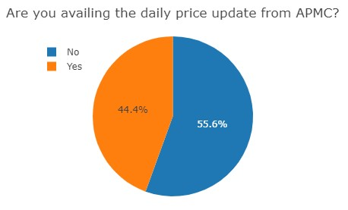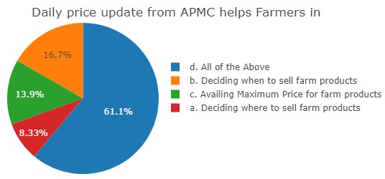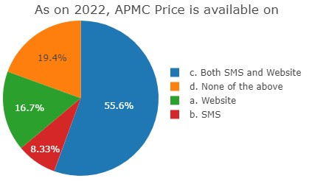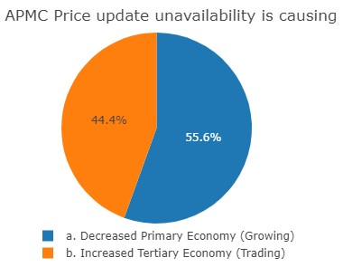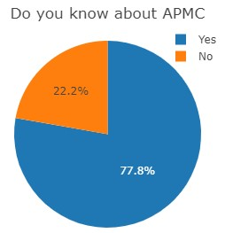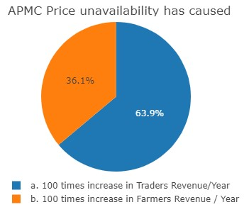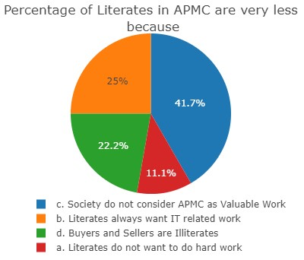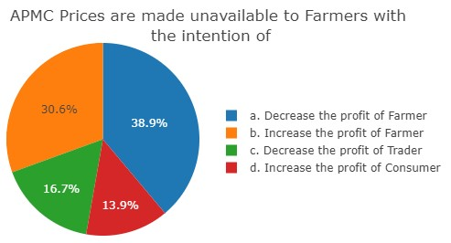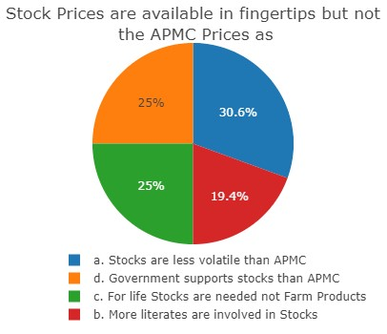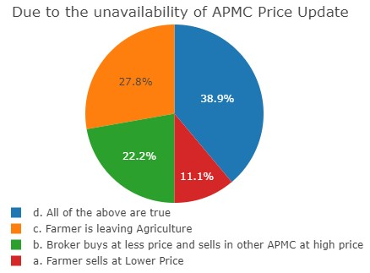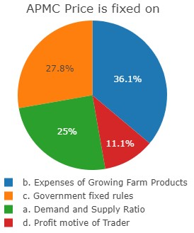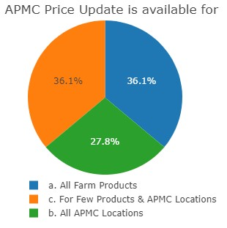

## Appendix 02 Field Visit Summary

As a part of the project, visit is made to the nearest APMC and interactions are made to understand the ongoings. Summary is listed here.

1. Name of the APMC Market:
2. Google Map Location of the APMC Market:
3. Reason for selecting this location for Field Visit:
4. Relevance of this location to the Project:
5. List the answers captured from APMC Staff:
   * 1. List of Products auctioned in APMC
     2. Number of Shops in APMC
     3. Products Auction time of APMC
     4. APMC Price update system available to Farmers:
6. List the answers captured from Seller / Farmer in APMC Staff:
   * 1. List of Products auctioned in APMC
     2. Number of Shops in APMC
     3. Products Auction time of APMC
     4. APMC Price update system available to Farmers:
7. List the answers captured from Trader in APMC:
   * 1. List of Products auctioned in APMC
     2. Number of Shops in APMC
     3. Products Auction time of APMC
     4. APMC Price update system available to Farmers:
8. List any technology found in APMC that provides information to Farmers.
9. List the available opportunity for the introduction of technology in APMC Price Updation to Farmers
10. List the price of any 5 products in APMC and compare with the price in
    * + - APMC Website - o <https://enam.gov.in/web/dashboard/trade-data>o <https://www.krishimaratavahini.kar.nic.in/reports/Main_Rep.aspx>
        - Bigbasket Website

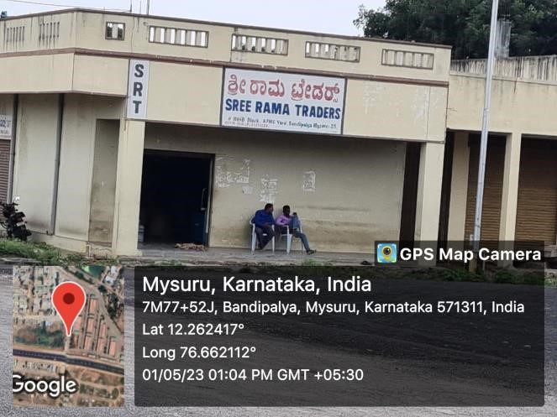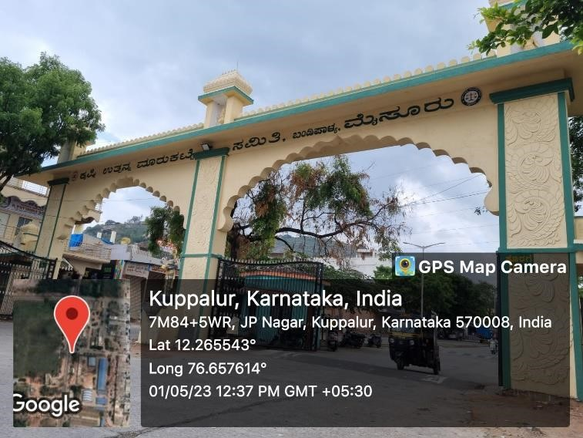

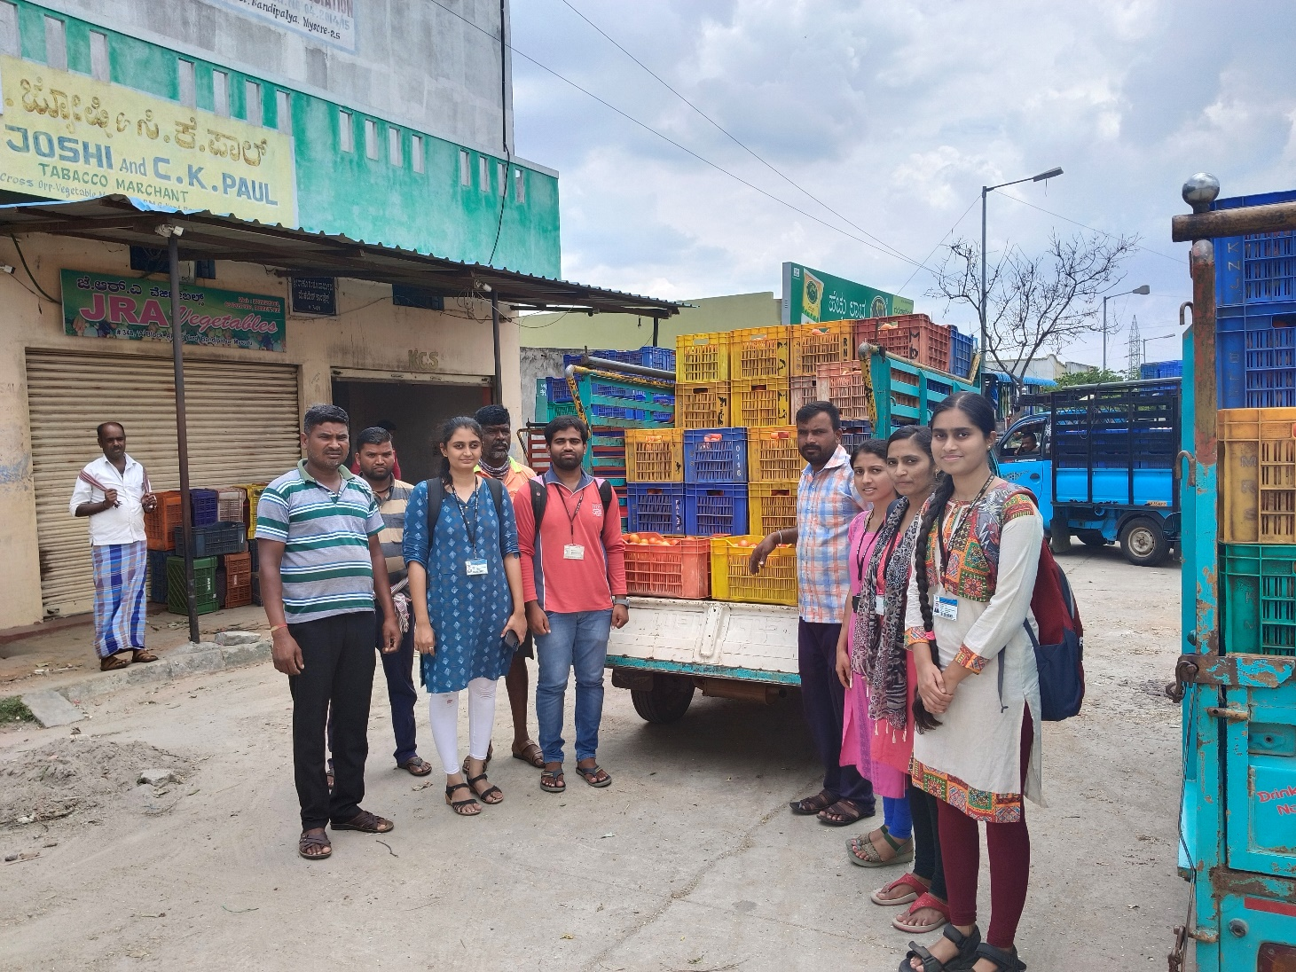

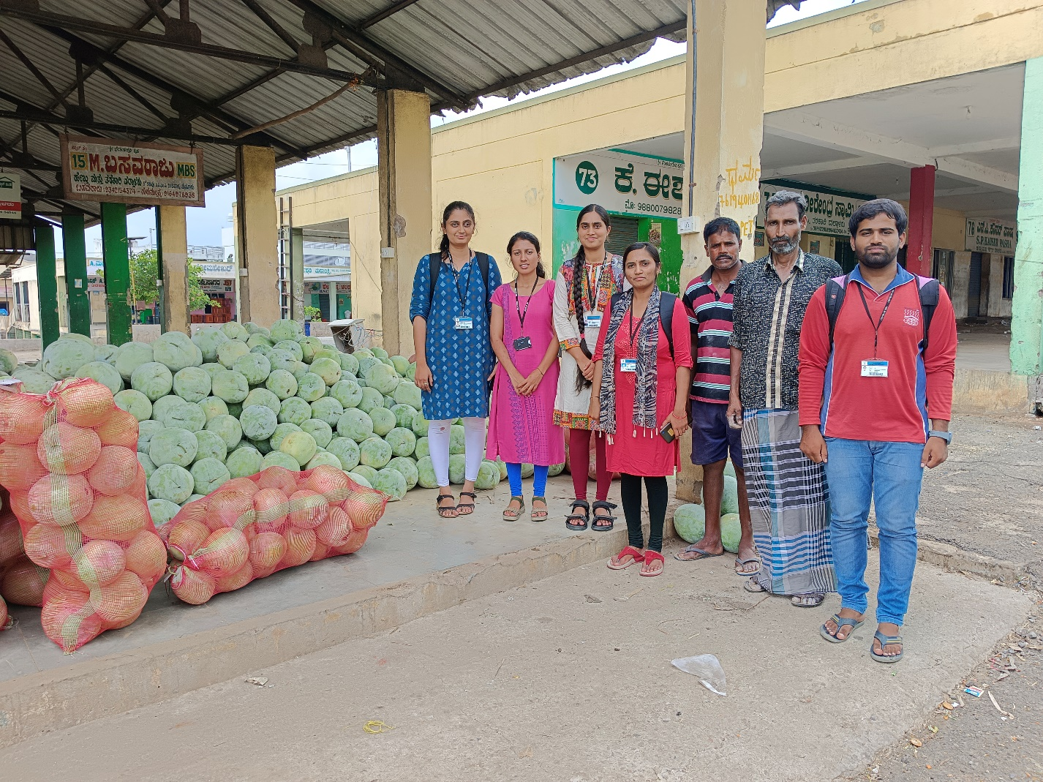

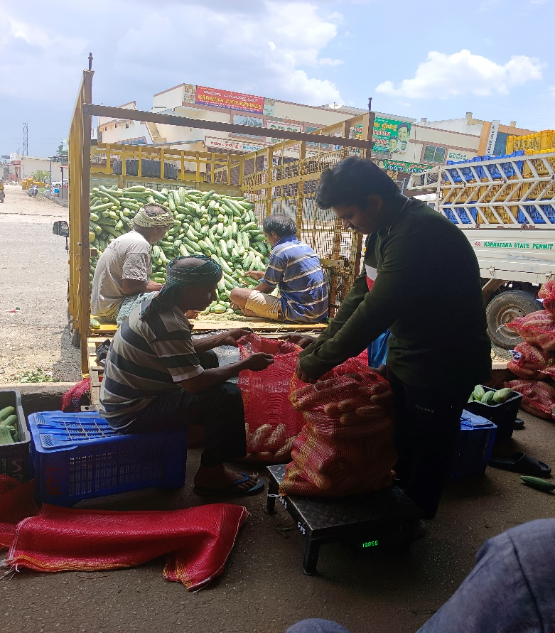

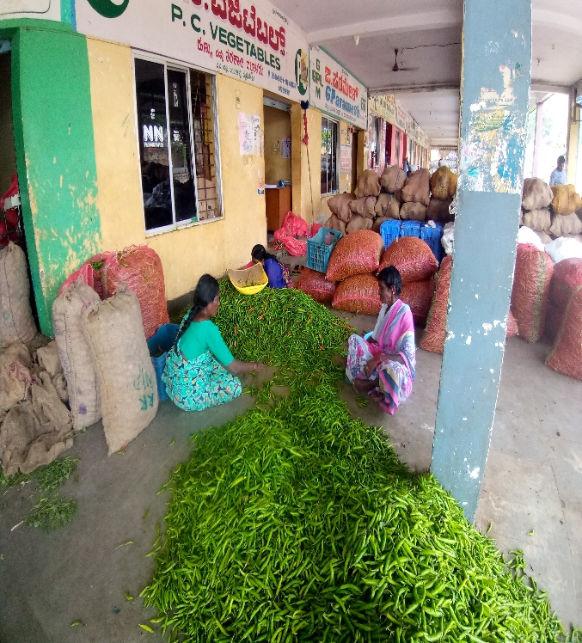

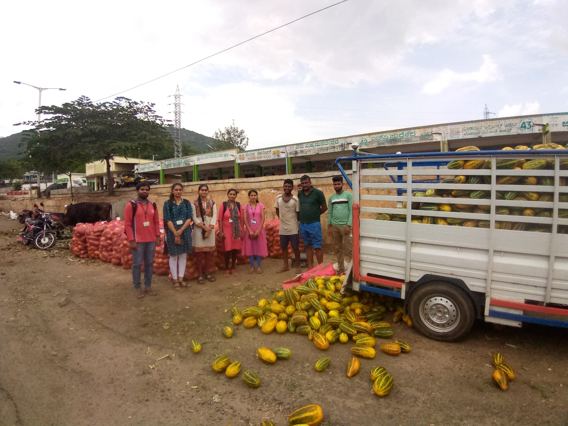

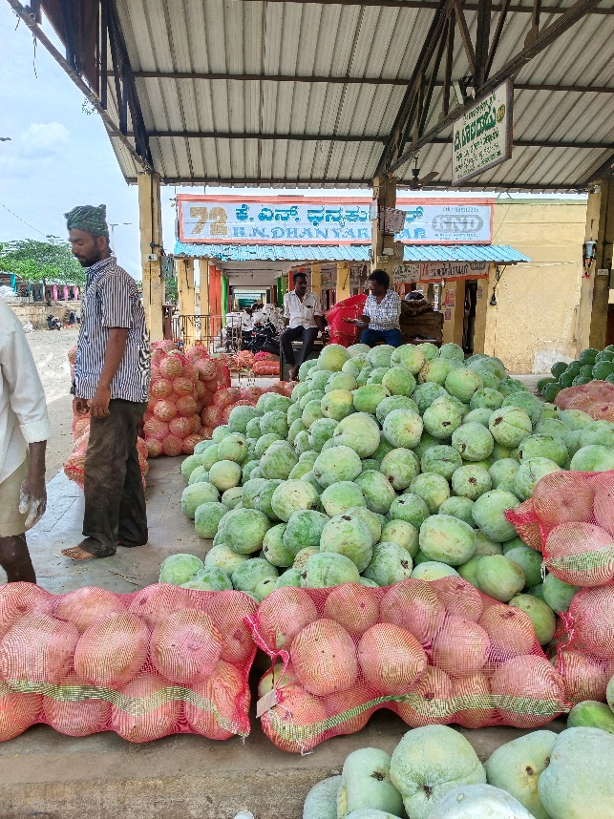

1.APMC ,Bandipalya,Mysore

2.7M67+W35 Vegetable Market, Bandipalya, Mysuru, Karnataka 570025

3.This APMC is the largest APMC markrt in Mysore,

4.This market contains the shops that are run by all the persons like traders, farmers etc..

* 1. onions,tomoto,peas,cauliflower,beans etc
  2. 92 shops
  3. 6.30 a.m to 2.30 p.m
  4. SMS to the farmer
  5. onions,tomoto,peas,cauliflower,beans etc
  6. 85
  7. 6.30 a.m to 12.30 p.m
  8. SMS to the farmer
  9. onions,tomoto,peas,cauliflower,beans etc
  10. 88
  11. 6.30 a.m to 1.30 p.m
  12. SMS to the farmer

1. Electronic Board
2. SMS,Application

10.Beans - APMC- Rs 48/Kg

BigBasket- Rs 50/Kg

Cauliflower - APMC- Rs 22/Kg

BigBasket- Rs 28/Piece

Tomato - APMC- Rs 5/Kg

BigBasket- Rs 14/Kg

Onion - APMC- Rs 10/Kg

BigBasket- Rs 21/Kg

Banana - APMC- Rs 18/Kg

BigBasket- Rs 37/Kg

## Appendix 03 Providing Solution as an Engineer

Solutions are provided to the following problem statements as an Engineer

1. Explain possible technology adoption to update the APMC Price to Farmers
2. Introduce the Engineering Solution for digital Illiterates that can provide APMC Price update
3. Explain the scope of Artificial Intelligence in APMC Price Update System
4. Explain the scope of Satellite Imaging in balancing Demand and Supply ratio of Farm Products
5. Explain the reason for the failure of Online APMC Auction Project of Government. Refer this link for the reference -<https://enam.gov.in/web/dashboard/trade-data>**Solutions**:

1.The Agriculture Produce Market Committee (APMC) is a regulated market where farmers can sell their agricultural produce through authorized intermediaries, such as commission agents, traders, and processors. Farmers can get APMC price updates through various channels, including:

APMC website: Many APMC markets have their website, where they regularly update the prices of different crops traded in the market. Farmers can access the website and check the current prices of their produce. SMS alerts: Some APMC markets also provide SMS alerts to registered farmers about the latest prices of crops. Farmers can subscribe to these alerts by registering their mobile numbers with the APMC market office.

Toll-free number: Some APMC markets have a toll-free number that farmers can call to know the latest prices of their produce. They can also get information on the prevailing market trends and demand for various crops.

Market information service providers: Some private companies offer market information services to farmers. These companies collect real-time data from APMC markets and provide price updates to farmers through SMS, mobile apps, and web portals.

Kisan Call Centre: The Indian government's Kisan Call Centre provides a toll-free helpline number (1800180-1551) that farmers can call to get information on crop prices, weather, and other agriculture-related queries.

State agriculture department: State agriculture departments also provide price updates on different crops. Farmers can contact their local agriculture office or visit their website to get the latest price information. In conclusion, farmers have several options to get APMC price updates, including accessing APMC market websites, subscribing to SMS alerts, calling toll-free numbers, using market information services, contacting Kisan Call Centre, and consulting state agriculture departments. By staying updated on the latest market trends, farmers can make informed decisions about when and where to sell their produce to get the best price.

2.Getting a price forecast for the next 7 days can help farmers plan their crop sales and make informed decisions. Here are some ways to avail APMC price forecasts for the next 7 days:

APMC website: Some APMC markets provide price forecasts for the next 7 days on their website. Farmers can check the website to get an idea of the expected prices of their crops in the coming week.

Market information service providers: Private companies that offer market information services to farmers may also provide price forecasts for the next 7 days. These companies collect data from APMC markets and use advanced analytics and machine learning models to forecast prices. Farmers can subscribe to these services to get regular price forecasts.

Mobile apps: Some APMC markets have mobile apps that farmers can download to get price forecasts for the next 7 days. These apps provide real-time updates on prices and market trends and can help farmers make informed decisions.

SMS alerts: Farmers can also subscribe to SMS alerts that provide price forecasts for the next 7 days. These alerts can be sent directly to their mobile phones, making it easy for them to stay updated on market trends.

State agriculture department: State agriculture departments may also provide price forecasts for the next 7 days. Farmers can contact their local agriculture office or visit the department's website to get the latest price information.

In conclusion, farmers have several options to avail APMC price forecasts for the next 7 days, including accessing APMC market websites, subscribing to market information services, using mobile apps, receiving SMS alerts, and contacting state agriculture departments. By staying updated on the price trends, farmers can make informed decisions about when to sell their crops and get the best possible price.

3.The APMC system is a regulated market where farmers can sell their agricultural produce through authorized intermediaries. Currently, the APMC system operates on an auction system where buyers bid for the produce, and the highest bidder purchases the produce. However, there is a growing demand to replace the auction system with an assured price system to provide more stable and sustainable sales for farmers.

Here are some advantages and disadvantages of the assured price system:

Advantages:

Price stability: Under the assured price system, farmers are guaranteed a fixed price for their produce. This can provide stability and certainty to farmers and help them plan their finances better.

Fair pricing: The assured price system can help ensure that farmers get a fair price for their produce. In an auction system, the price can fluctuate widely depending on the demand and supply, which can be unpredictable and unfair to farmers.

Encourages cultivation of high-value crops: With assured prices for high-value crops, farmers may be incentivized to grow crops that have higher market demand and better profitability.

Reduced risk: The assured price system can reduce the risk for farmers as they are assured of getting a fixed price for their produce, even if there is a surplus in the market.

Disadvantages:

Market distortions: The assured price system can distort the market by creating artificial demand for certain crops, which may lead to an oversupply of that crop in the market.

Higher costs: The assured price system can lead to higher costs for buyers, as they may have to pay a higher price for the produce.

Lack of market competitiveness: With assured prices, there may be less competition among buyers, which can result in a lack of market competitiveness.

Implementation challenges: The implementation of the assured price system can be challenging, as it requires coordination among various stakeholders, including farmers, buyers, and regulators.

4.Knowing the APMC price for a particular crop is one thing, but selling the crop in the APMC market at that price is another. Many farmers face challenges in selling their produce in the APMC market, especially if they are not familiar with the market dynamics or lack access to transportation or storage facilities. Let's take the example of carrot farm products to understand this better.

Suppose a farmer in a village produces carrots and has heard that the current APMC price for carrots is Rs. 20 per kilogram. However, the farmer does not have a clear idea of how to sell their produce in the APMC market at that price. Here are some of the challenges they may face:

Transportation: The farmer may not have access to transportation facilities to transport their produce to the APMC market. Even if they do, the transportation cost may be high, cutting into their profits.

Storage: The farmer may not have access to proper storage facilities to store their produce before selling it in the market. If the produce is not stored properly, it may get spoiled, leading to a loss for the farmer.

Quality: The farmer may not be able to ensure that the quality of their produce meets the standards required by the APMC market. If the quality is not up to the mark, the farmer may not be able to sell their produce at the expected price. Competition: The APMC market may have many other sellers of carrots, leading to competition, and making it difficult for the farmer to sell their produce at the expected price.

To overcome these challenges, the farmer may need to take certain steps. For example, they may need to collaborate with other farmers in their area to share transportation and storage costs. They may also need to invest in proper storage facilities to store their produce before selling it in the market. The farmer may also need to ensure that the quality of their produce meets the standards required by the APMC market by following good agricultural practices.

In conclusion, while knowing the APMC price for a crop is important, selling the crop at that price in the APMC market can be challenging for farmers. Farmers may need to take certain steps, such as collaborating with other farmers, investing in proper storage facilities, and following good agricultural practices, to overcome these challenges and sell their produce at the expected price.

5.The statement "Local brokers service is better than APMC in trading the farm products" is subjective and depends on various factors. Both local brokers and APMC have their advantages and disadvantages in trading farm products. Advantages of Local Brokers:

Personalized service: Local brokers provide personalized services to farmers, which may include advice on pricing, transportation, and storage.

Better market knowledge: Local brokers have better knowledge of the local market conditions, including demand and supply, which may help farmers in making better pricing decisions.

Flexibility: Local brokers offer more flexibility in terms of selling the produce, as they may be willing to buy smaller quantities and may offer better payment terms.

Advantages of APMC:

Price transparency: APMC provides price transparency to farmers, as the prices are determined through an auction system, which is open to all buyers.

Standardization: APMC ensures standardization of quality and grading of the produce, which may help farmers in getting better prices for their produce.

Legal protection: APMC provides legal protection to farmers in case of disputes with buyers or brokers, as it is regulated by the government.

Disadvantages of Local Brokers:

Lack of standardization: Local brokers may not follow standard practices for grading and quality control, which may result in lower prices for the farmers.

Price fluctuations: Local brokers may offer fluctuating prices depending on the demand and supply in the market, which may result in uncertainty for the farmers.

Payment delays: Local brokers may delay payments to farmers, which may result in financial difficulties for the farmers.

## Appendix 04 Case Study Questions

1. Explain the purpose of APMC Establishment in India
2. List the Total Number of APMC in your state and Names of APMC in your district
3. APMC needs equal participation of Agent, Buyer and Farmer. Is this ratio practically achieved.? If not, who is dominating the APMC
4. List the necessity of streaming Live Prices of APMC to Farmers.
5. Explain whether Live Price update of APMC is advantageous or disadvantageous to following stakeholders of APMC with reasons
   * Government
   * Farmers
   * APMC Agents
   * Traders
   * Public
   * National Economy
6. List the Price update system available in APMC of any other country
7. Explain the “Farmers Produce Trade and Commerce (Promotion & Facilitation) Act, 2020”
8. Are farmers using the present method of Price Updation by APMC. Is this user friendly mode to farmer.?
9. List the Private Companies working on APMC Price Updation.
10. If Milk price can be fixed why not the other Farm Products..?? Explain

ANSWER:

1. The Agricultural Produce Market Committee (APMC) is a statutory body that was established by the government of India with the aim of regulating the marketing of agricultural produce in the country. The purpose of establishing APMC is to ensure that farmers are given a fair and transparent price for their agricultural produce and to protect them from the exploitation of middlemen.

The APMC provides a platform for farmers to sell their produce

1. Karnataka state has a total of 157 APMC markets spread across various districts.

Mysore district in Karnataka has 5 APMC markets. The names of these markets are:

1. Mysore APMC, Bandipalya
2. Nanjangud APMC, Nanjangud
3. H.D. Kote APMC, H.D. Kote
4. K.R. Nagar APMC, K.R. Nagar
5. Periyapatna APMC, Periyapatna
6. APMC system is designed to ensure equal participation of agents, buyers, and farmers in the market. However, in practice, the actual ratio of participation may vary from market to market and from state to state.

In some cases, the dominance of certain groups or individuals in the APMC system has been a concern. For example, in some markets, a small group of traders or commission agents may have a disproportionate influence over the market, which can result in unfair practices or pricing. Similarly, in some cases, farmers may be at a disadvantage due to their limited bargaining power or lack of access to market information. To address these issues, various reforms have been proposed to increase competition and transparency in the APMC system. For example, some states have introduced electronic trading platforms, which enable farmers to access market information and sell their produce directly to buyers. Other reforms have focused on improving the infrastructure and facilities in APMC markets, to ensure that all participants have equal access to the market.

Overall, while the APMC system has its challenges, it remains an important mechanism for providing a regulated market for agricultural produce in India. By ensuring equal participation of all stakeholders and promoting fair pricing and practices, the APMC system can help to support the livelihoods of farmers and promote the growth of India's agricultural sector.

1. Streaming live prices of agricultural produce to farmers through the Agricultural Produce Market Committee (APMC) can provide several benefits to the farmers, including:

1.Price Transparency: Live streaming of prices of agricultural commodities on APMC platforms can increase transparency and help farmers make informed decisions about when and where to sell their produce. They can get an idea of the current market price for their produce and can avoid being cheated by middlemen.

2.Real-Time Information: By providing real-time information on market prices, farmers can better plan their sales and improve their bargaining power. They can also make decisions about which crops to grow based on market demand and pricing trends.

3.Better Market Access: Live streaming of prices on APMC platforms can provide farmers with better market access. They can reach a wider range of buyers and get better prices for their produce.

1. Government:

Advantages: Live price updates can help the government monitor market prices and ensure that farmers are getting a fair price for their produce.

Disadvantages: The live price updates can also expose the inefficiencies and unfair practices within the APMC system, which can be embarrassing for the government.

Farmers:

Advantages: Live price updates can help farmers make informed decisions on when to sell their produce and where to sell it.

Disadvantages: Live price updates can also increase competition among farmers, which can lead to a race to the bottom in terms of prices.

APMC Agents:

Advantages: Live price updates can help APMC agents to make informed decisions on when to buy and sell produce.

Disadvantages: Live price updates can also expose the inefficiencies and unfair practices within the APMC system, which can reduce the bargaining power of APMC agents.

Traders:

Advantages: Live price updates can help traders to make informed decisions on when to buy and sell produce.

Disadvantages: Live price updates can also expose the inefficiencies and unfair practices within the APMC system, which can reduce the bargaining power of traders.

Public:

Advantages: Live price updates can help consumers make informed decisions on when and where to buy produce.

Disadvantages: Live price updates can also increase the volatility of prices, which can be challenging for consumers who rely on stable prices to plan their budgets.

National Economy:

Advantages: Live price updates can help the national economy by increasing the efficiency and transparency of the agricultural market.

Disadvantages: Live price updates can also expose the inefficiencies and unfair practices within the APMC system, which can reduce the competitiveness of Indian agriculture and impact the overall economic growth.

1. There are different systems available in various countries for updating prices in APMCs or similar marketplaces. Here are a few examples:

India - Agmarknet: Agmarknet is an online platform developed by the Ministry of Agriculture and Farmers' Welfare, Government of India, which provides daily market prices of different agricultural commodities in various APMCs across the country. The prices are updated by APMCs and other agencies at regular intervals.

United States - USDA Market News: The United States Department of Agriculture (USDA) provides market news services that report on market conditions, prices, supply and demand, and other market-related information for agricultural commodities. The reports are prepared by USDA market reporters who visit APMCs, packers, processors, and other market participants to collect and disseminate the latest market information.

Australia - Market Information System: The Australian government provides an online Market Information System that provides market prices for various agricultural commodities across different APMCs in the country. The prices are updated regularly and are collected from APMCs and other market participants.

1. The Farmers' Produce Trade and Commerce (Promotion and Facilitation) Act, 2020 is a law enacted by the Parliament of India in September 2020. It aims to provide a framework for farmers to sell their agricultural produce outside the physical premises of APMC markets or mandis.

Under this act, farmers have the freedom to sell their produce to anyone, anywhere in the country. They are not bound to sell their produce only to APMC-licensed traders within the mandis. They can sell their produce directly to processors, exporters, or any other buyer of their choice, and negotiate prices and conditions directly with them. This act aims to promote competition and increase the farmers' bargaining power by removing intermediaries from the supply chain.

The Act provides for the establishment of electronic trading platforms or e-trading platforms, where farmers and buyers can transact business online. This will help farmers to get better prices for their produce, as they can access a wider market, beyond their local mandis.

1. The present method of price updation by APMC varies from state to state in India, and its usability and user-friendliness depend on various factors such as access to technology, literacy levels, and awareness among farmers.

While some farmers may find the APMC price updation system user-friendly, others may face challenges in accessing and interpreting the information. Some farmers may also rely on other sources of information, such as local traders or middlemen, rather than APMC price updates.

However, with the increasing availability of mobile phones and the internet, many APMCs have started using online platforms and mobile applications to update prices, making it easier for farmers to access price information. The Indian government has also launched initiatives like eNAM (Electronic National Agriculture Market), which aims to integrate APMCs across the country and provide farmers with a more transparent and efficient marketplace.

Overall, while the present method of price updation by APMC may have its limitations, efforts are being made to make it more user-friendly and accessible to farmers. The use of technology and online platforms is expected to improve the transparency and efficiency of agricultural markets and benefit farmers in the long run.

1. There are several private companies working on APMC price updation in India. Here are a few examples: AgroStar: AgroStar is an agri-tech startup that provides agricultural inputs, crop advisory services, and market price information to farmers. The company has tied up with various APMCs in different states to provide live price updates of agricultural commodities through its mobile application.

Ninjacart: Ninjacart is a Bengaluru-based agri-tech startup that connects farmers with retailers and consumers through its supply chain network. The company provides real-time price updates of different agricultural commodities to its network of farmers, helping them to get better prices for their produce.

RML AgTech: RML AgTech is an agri-tech company that provides market information and intelligence services to farmers, traders, and other stakeholders in the agriculture sector. The company has developed a mobile application called 'Agri Market' that provides live price updates of various agricultural commodities in different APMCs across the country.

EM3 AgriServices: EM3 AgriServices is an agri-tech company that provides farm mechanization services and other agri-services to farmers. The company has also launched an online platform called 'AgriPrice' that provides real-time price updates of agricultural commodities in different APMCs across the country

1. Milk prices are fixed by government agencies or cooperatives because the milk industry has a wellestablished supply chain and distribution system, and milk is a perishable commodity that requires immediate processing and distribution.

The milk industry is highly organized, and the entire process of milk collection, processing, and distribution is regulated and monitored by government agencies or cooperatives. As a result, it is easier to fix milk prices based on factors such as quality, fat content, and volume.

However, fixing prices for other farm products may not be as simple because the supply chain and distribution systems for different agricultural commodities can be complex and fragmented.

For example, in the case of fruits and vegetables, prices may be influenced by factors such as seasonality, transportation costs, and storage conditions, making it challenging to fix prices based on a set formula. Moreover, fixing prices for agricultural commodities may not always be feasible, as prices can be influenced by factors such as demand and supply, weather conditions, and international trade policies.

Therefore, while it may be possible to fix prices for some agricultural commodities, it may not be a practical solution for others due to the complexities involved in their supply chain and distribution systems. Instead, efforts should be made to create a transparent and efficient marketplace that enables farmers to get fair prices for their produce.